### CERTIFICATE

This is to certify that this Project Report entitled “**Movie Streaming Website/ Netflix Clone**” which is submitted by **Mr. Vikas nolke** university Roll no **1816699** in the partial fulfillment, for the award of the degree of Bachelor of Technology in Department of Electronics & communication Engineering, of Chandigarh Engineering College Jhanjeri, Mohali affiliated to I.K. Gujral Punjab Technical University, Jalandhar, is carried out by them under my supervision.

This matter embodied in this project work has not been submitted earlier for award of any degree or diploma in any university/institution to the best of our knowledge and belief.

Name of Project Guide Dr. Pardeep jindal

(Designation, Department) (HOD,ECE)

Signature with Date Signature with Date

**ACKNOWLEDGEMENT**

It is great pleasure to present this report on the **project title** “**Movie Streaming Website/ Netflix Clone**” undertaken by me as part of my B.Tech degree in Electronics &

communication Engineering final year. I am thankful to my university for offering me such a wonderful challenging opportunity and I express my deepest thanks to all coordinators, for providing all the possible help and assistance and their constant encouragements.

I am extremely thankful to **Dr. Sajjan Singh,** HOD, Electronics & Communication Engineering, Chandigarh Engineering College Jhanjeri, Mohali (Punjab) for valuable suggestions and motivation.

I am also thankful to all my Teachers who have taught me throughout my Degree and the management, Principal of Chandigarh Engineering College Jhanjeri, Mohali (Punjab), for providing the opportunity to get the knowledge.

**Signature of Student**

**CHANDIGARH ENGINEERING COLLEGE,**

**JHANJERI, MOHALI**

**DECLARATION**

I, **Vikas nolke** hereby declare that the report of the project entitled “**Movie Streaming Website/ Netflix Clone**” has not presented as a part of any other academic work to get my degree or certificate except Chandigarh Engineering College Jhanjeri, Mohali, affiliated to I.K. Gujral Punjab Technical University, Jalandhar, for the fulfillment of the requirements for the degree of B.Tech in Electronics & Communication Engineering.

## *Vikas nolke*

1816699

8th Semester

Student Signature with Date

**ABSTRACT**

This project is client-based web application and it helps to earn revenue for administrator from paid subscribers. In this system the administrator has all rights of manipulating the data, subscribers can see uploaded videos on the website as well as the list of upcoming movies.

With streaming video or streaming media, a Web user does not have to wait to download a file to play it.  Subscribed user can watch the videos online. The registered user will have to pay the subscription charge to stream videos.

**TABLE OF CONTENTS**

|  |  |  |
| --- | --- | --- |
|  | CONTENTS | PAGE NO. |
| 1. | Abstract | 1 |
| 2. | Introduction | 2-10 |
| 3. | Softwares and Tools Used | 11-19 |
| 4. | Screenshots | 20-24 |
| 5. | References | 25 |

**INTRODUCTION TO ORGANISATION**

# About Our Company (Oceana Tech In)

Digital Aspire, a certified Career Enhancement Training company offers students an opportunity to enhance their technical skills and give a cutting-edge to their professional career by introducing them to the latest technologies. We at Digital Aspire also provide students with training to develop live projects.

We at Digital Aspire also provide students with training to develop live projects and cover basic plus advance topics. Ensuring they strike gold with best of the companies, our industry experts provide training for soft skills development and interview preparation.

# Our Mission And Vision

The mission and vision of our career enhancement training program are focused on offering the best guidance to our students when it is about growing their careers:

* Offer technical and soft skill training to students in a constructive environment.
* To make the students realize their maximum potential and evolve as skilled professionals in respective industry.
* We share a vision to nurture professionals by offering them an enriched experience.
* Ensuring they strike gold with best of the companies.
* Provide training for soft skills development and interview preparation.

**INTRODUCTION**

**2.1 Introduction –**

Web development refers to building, creating, and an maintaining websites. It includes aspects such as [web design](https://techterms.com/definition/web_design), [web publishing](https://techterms.com/definition/web_publishing), web programming, and [database](https://techterms.com/definition/database) management.

While the terms "web developer" and "web designer" are often used synonymously, they do not mean the same thing. Technically, a web designer only designs website interfaces using [HTML](https://techterms.com/definition/html) and [CSS](https://techterms.com/definition/css). A web developer may be involved in designing a website, Additionally, a web developer may help maintain and update a database used by a [dynamic website](https://techterms.com/definition/dynamicwebsite).

Web development includes many types of web content creation. Some examples include hand coding web pages in a [text editor](https://techterms.com/definition/texteditor), building a website in a program like Dreamweaver, and updating a [blog](https://techterms.com/definition/blog) via a blogging website. In recent years, content management systems like WordPress, Drupal, and Joomla have also become popular means of web development. These tools make it easy for anyone to create and edit their own website using a web-based [interface](https://techterms.com/definition/interface).

While there are several methods of creating websites, there is often a trade-off between simplicity and customization. Therefore, most large businesses do not use content management systems, but instead have a dedicated Web development team that designs and maintains the company's website(s). Small organizations and individuals are more likely to choose a solution like WordPress that provides a basic website [template](https://techterms.com/definition/template) and simplified editing tools.

**NOTE:** [JavaScript](https://techterms.com/definition/javascript) programming is a type of web development that is generally not considered part of web design. However, a web designer may reference JavaScript libraries like jQuery to incorporate dynamic elements into a site's design.

Streaming media is [multimedia](https://en.wikipedia.org/wiki/Multimedia) that is constantly received by and presented to an [end-user](https://en.wikipedia.org/wiki/End-user_(computer_science)) while being delivered by a provider. The verb *to stream* refers to the process of delivering or obtaining media in this manner. Streaming refers to the delivery method of the medium, rather than the medium itself. Distinguishing delivery method from the media distributed applies specifically to [telecommunications networks](https://en.wikipedia.org/wiki/Telecommunications_network), as most of the delivery systems are either inherently streaming (e.g. radio, television, streaming apps) or inherently non-streaming (e.g. books, [video cassettes](https://en.wikipedia.org/wiki/Videotape), audio CDs). There are challenges with streaming content on the Internet. For example, users whose Internet connection lacks sufficient [bandwidth](https://en.wikipedia.org/wiki/Bandwidth_(signal_processing)) may experience stops, lags, or slow buffering of the content. And users lacking compatible hardware or software systems may be unable to stream certain content.

Streaming is an alternative to file [downloading](https://en.wikipedia.org/wiki/Downloading), a process in which the end-user obtains the entire file for the content before watching or listening to it. Through streaming, an end-user can use their [media player](https://en.wikipedia.org/wiki/Media_player_(software)) to start playing [digital video](https://en.wikipedia.org/wiki/Digital_video) or [digital audio](https://en.wikipedia.org/wiki/Digital_audio) content before the entire file has been transmitted.

This project is client-based web application and it helps to earn revenue for administrator from paid subscribers. In this system the administrator has all rights of manipulating the data, subscribers can see uploaded videos on the website as well as the list of upcoming movies.

With streaming video or streaming media, a Web user does not have to wait to download a file to play it.  Subscribed user can watch the videos online. The registered user will have to pay the subscription charge to stream videos.

**2.2 Evolution of Streaming Services -**

In the early stages of the Internet, a Dial-Up connection was necessary in order to start browsing the web.  The user would use a telephone network to establish a connection with the Internet Service Provider.  A modem attached to the user’s computer would encode and decode information.  However, downloading a large data file would be nearly impossible, as a three-minute video would probably take a few hours to download.  When users ventured onto the Internet to watch moving pictures they would encounter a tiny matchbook sized image that, should they try to enlarge it would become severely pixelated (broken up unto mosaic like titles).  **(Klinger, 196)**

Video and sound wouldn’t match up most of the time as data had to be streamed through an unstable connection.  By the second half of the 1990’s, Apple, Real Networks and Microsoft produced streaming video players entitled, respectively, QuickTime, Real Video and Windows Media Player, enabling moving images to materialize on individual computers almost simultaneously with their transmission **(Klinger, 197).**  Using the same compression technologies designed for music, video players compressed and decompressed video information in real time, solving the problem of large data files.  Now users wouldn’t have to wait for a file to be downloaded in order to start watching it.

With the appearance of computers and broadband technologies, the Internet started to acquire status as a place where you could find more and more videos.  And while Internet is a place where users may find lots of content, Hollywood has been reluctant to fully adopt it out of piracy concerns and the amount of information that proliferates on cyberspace.

Broadband solutions such as DSL and cable modems provide greater speed and volume; as a result we are presented with faster and clearer transmission.  With high-speed Internet connections, audio and video are largely free of interference, a huge leap away from the dialup connection era.  **(Klinger, 197)**

The internet has become a communications platform that is arguable as pervasive, if not more pervasive, than any of our traditional mass media platforms, and its relative ease of access

(i.e., very low barriers to entry), individual Internet users stand on closer to equal footing with the traditional institutional communicators in terms of their access to the media. **(Napoli, 166)**

Some people might point out that the Internet is breaking paradigms and re-shaping the existing media business.   These people are pointing out the growing cascade of information and how hyperlinks are a way of dealing with it. Links to the right information can be extremely valuable –especially to companies that know how to use those links to their advantage. **(Rose, 111)**

**2.3 Efficiency of Streaming Services -**

Video and entertainment content now streams from websites and services like YouTube or Netflix, whatever TV show or movie show you are looking for the odds of finding it on the web are getting higher every day.

Streaming Video accelerates everything.  Now movies are released on streaming services just a few months after their release on theatres.  A whole season for a TV show can be found on the web and binged watched in just one weekend.  With his new service, users now have a voracious appetite for new content.

The media industry much like the print industry when e-books first appeared has to adapt to this new consumption model. Long gone are the days where movie enthusiasts started a DVD or VHS collection and showed it proudly to visitors.  With streaming technology and online movies when you buy something you don’t really own it. Now everything resides within a cloud storage service where we have a false sense of belonging.

Video Streaming and broadband connections help users around the globe download and watch large video files from the comfort of their homes.  Taking advantage of this technology, the American company Netflix launched a video streaming website on 2009 where users could watch the most recent Television episodes and Hollywood Blockbusters.

Some other examples include streaming services like [Hulu](https://en.wikipedia.org/wiki/Hulu), [Prime Video](https://en.wikipedia.org/wiki/Prime_Video), the [video sharing website](https://en.wikipedia.org/wiki/Video_sharing_website) YouTube, and other sites which stream films and television shows; [Apple Music](https://en.wikipedia.org/wiki/Apple_Music) and [Spotify](https://en.wikipedia.org/wiki/Spotify), which stream music; and [video game live streaming](https://en.wikipedia.org/wiki/Video_game_live_streaming) sites such as [Mixer](https://en.wikipedia.org/wiki/Mixer_(website)) and [Twitch](https://en.wikipedia.org/wiki/Twitch_(service)).

Netflix’s instant streaming service over the Internet is witnessing escalating growth.  There are various devices worldwide that can stream content from Netflix instantly. These include the Microsoft Xbox 360, Nintendo Wii and Sony PS3 Consoles; Blu-Ray disc players, Internet-connected TVs, home theatre systems, digital video recorders and Internet Video Players; Apple iPhone, iPad and iPod touch, Android devices, as well as Apple TV and Google TV.  Devices such as the iPhone, iPad and iPod touch enable viewers to watch movies and TV shows while on the move.

For today’s audiences it’s all about immediacy and mobility, the content they are looking for must be just a click away to fit their needs.  Now everything is possible.  Maybe you want to watch an episode of your favourite show when you are traveling, or maybe each member of your family wants to watch something different in a separate room of the house.

All of these demands are being fulfilled with the help of video streaming as well as the proliferation of devices that gives the user access to it.  Now if you want to play movies, music or watch an episode of your favourite TV show you can easily do it wherever you may be.

That is where user profiles come in. Separate user profiles are handy if there is more than one person using a single account. They allow multiple users to access streaming content under one login, and can keep recommendations and viewing histories intact for each individual user, rather than have the service work out a rough amalgamation for everyone.

After Netflix, Amazon Prime has also introduced user profiles to its service for the first time. Users can manage 5 profiles on Netflix and 6 profiles on Prime respectively.

**2.4 Advantages of Streaming Services -**

**2.4.1 Instant Viewing**

All of these demands are being fulfilled with the help of video streaming as well as the proliferation of devices that gives the user access to it.  Now if you want to play movies, music or watch an episode of your favourite TV show you can easily do it wherever you may be.

**2.4.2 No Download Time**

Streaming platforms have made it simpler for people to watch their favourite shows without worrying about download time. All you need is a stable internet connection for you to watch any show.

**2.4.3 No Need for Memory Space**

Since there are no downloads involved, you don’t have to worry about running out of disk space or memory space. Downloading huge videos to your computer may take up vast spaces on your computer, which may affect the performances of your computer.

**2.4.4 Many Streaming Options**

**Stre**aming websites offer you a chance of choosing from their huge list of options. There are no limits as to how many videos you can watch in a day, as long as you have paid your subscription.

**2.5 History of Netflix -**

Netflix, Inc. is an American [over-the-top content platform](https://en.wikipedia.org/wiki/Over-the-top_media_services) and [production company](https://en.wikipedia.org/wiki/Production_company) headquartered in [Los Gatos, California](https://en.wikipedia.org/wiki/Los_Gatos,_California). Netflix was founded in 1997 by [Reed Hastings](https://en.wikipedia.org/wiki/Reed_Hastings) and [Marc Randolph](https://en.wikipedia.org/wiki/Marc_Randolph) in [Scotts Valley, California](https://en.wikipedia.org/wiki/Scotts_Valley,_California). The company's primary business is a subscription-based [streaming service](https://en.wikipedia.org/wiki/Streaming_service_provider) offering online streaming from a library of films and television series, including those produced in-house. As of October 2020, Netflix had over 195 million paid subscriptions worldwide, including 73 million in the United States. It is available worldwide except in the following: mainland China (due to local restrictions), [Syria](https://en.wikipedia.org/wiki/Syria), [North Korea](https://en.wikipedia.org/wiki/North_Korea), and [Crimea](https://en.wikipedia.org/wiki/Crimea) (due to US sanctions). It was reported in 2020 that Netflix's operating income is $1.2 billion. The company has offices in France, the United Kingdom, Brazil, the Netherlands, India, Japan, and South Korea. Netflix is a member of the [Motion Picture Association](https://en.wikipedia.org/wiki/Motion_Picture_Association) (MPA), producing and distributing content from countries all over the globe.

Netflix's initial business model included [DVD](https://en.wikipedia.org/wiki/DVD) sales and rental by mail, but Hastings abandoned the sales about a year after the company's founding to focus on the initial DVD rental business. Netflix expanded its business in 2007 with the introduction of streaming media while retaining the DVD and Blu-ray rental business. The company expanded internationally in 2010 with streaming available in Canada, followed by Latin America and the Caribbean. Netflix entered the content-production industry in 2013, debuting its first series [*House of Cards*](https://en.wikipedia.org/wiki/House_of_Cards_(American_TV_series)).

Since 2012, Netflix has taken more of an active role as producer and distributor for both film and television series, and to that end, offers a variety of "[Netflix Original](https://en.wikipedia.org/wiki/List_of_Netflix_original_programming)" content through its online library. By January 2016, Netflix services operated in more than 190 countries. Netflix released an estimated 126 [original series](https://en.wikipedia.org/wiki/Original_series) and films in 2016, more than any other network or cable channel. Their efforts to produce new content, secure the rights for additional content, and diversify through 190 countries have resulted in the company racking up billions in debt: $21.9 billion as of September 2017, up from $16.8 billion from the previous year. $6.5 billion of this is long-term debt, with the remainder in long-term obligations. In October 2018, Netflix announced it would raise another $2 billion in debt to help fund new content. On July 10, 2020, Netflix became the largest entertainment/media company by [market capitalization](https://en.wikipedia.org/wiki/Market_capitalization).

Netflix introduced the monthly subscription concept in September 1999, and then dropped the single-rental model in early 2000. Since that time (see [Technical details of Netflix](https://en.wikipedia.org/wiki/Technical_details_of_Netflix)), the company has built its reputation on the business model of flat-fee unlimited rentals without due dates, late fees, shipping and handling fees, or per-title rental fees.

In 2000, when Netflix had just about 300,000 subscribers and relied on the US Postal Service for the delivery of their DVDs, their losses would total $57 million and offered to be acquired by [Blockbuster](https://en.wikipedia.org/wiki/Blockbuster_LLC) for $50 million. They proposed that Netflix, which would be renamed as Blockbuster.com, would handle the online business, while Blockbuster would take care of the DVDs, making them less dependent on the US Postal Service. The offer was declined.

Netflix initiated an [initial public offering](https://en.wikipedia.org/wiki/Initial_public_offering) (IPO) on May 29, 2002, selling 5.5 million shares of [common stock](https://en.wikipedia.org/wiki/Common_stock) at the price of US$15.00 per share. On June 14, 2002, the company sold an additional 825,000 shares of common stock at the same price. After incurring substantial losses during its first few years, Netflix posted its first profit during the fiscal year 2003, earning US$6.5 million profit on revenues of US$272 million. In 2005, 35,000 different films were available, and Netflix shipped 1 million DVDs out every day.

**TOOLS AND TECHNOLOGY USED**

**3.1 TOOLS:**

**3.1.1 Visual Studio Code**

Visual Studio Code, also commonly referred to as VS Code,[[9]](https://en.wikipedia.org/wiki/Visual_Studio_Code#cite_note-9) is a [source-code editor](https://en.wikipedia.org/wiki/Source-code_editor) made by [Microsoft](https://en.wikipedia.org/wiki/Microsoft) for [Windows](https://en.wikipedia.org/wiki/Windows), [Linux](https://en.wikipedia.org/wiki/Linux) and [macOS](https://en.wikipedia.org/wiki/MacOS).[[10]](https://en.wikipedia.org/wiki/Visual_Studio_Code#cite_note-TechCrunch-10) Features include support for [debugging](https://en.wikipedia.org/wiki/Debugging), [syntax highlighting](https://en.wikipedia.org/wiki/Syntax_highlighting), [intelligent code completion](https://en.wikipedia.org/wiki/Intelligent_code_completion), [snippets](https://en.wikipedia.org/wiki/Snippet_(programming)), [code refactoring](https://en.wikipedia.org/wiki/Code_refactoring), and embedded [Git](https://en.wikipedia.org/wiki/Git). Users can change the [theme](https://en.wikipedia.org/wiki/Theme_(computing)), [keyboard shortcuts](https://en.wikipedia.org/wiki/Keyboard_shortcut), preferences, and install [extensions](https://en.wikipedia.org/wiki/Plug-in_(computing)) that add additional functionality.

Visual Studio Code features a lightning fast source code editor, perfect for day-to-day use. With support for hundreds of languages, VS Code helps you be instantly productive with syntax highlighting, bracket-matching, auto-indentation, box-selection, snippets, and more. Intuitive keyboard shortcuts, easy customization and community-contributed keyboard shortcut mappings let you navigate your code with ease.

For serious coding, you'll often benefit from tools with more code understanding than just blocks of text. Visual Studio Code includes built-in support for IntelliSense code completion, rich semantic code understanding and navigation, and code refactoring.

And when the coding gets tough, the tough get debugging. Debugging is often the one feature that developers miss most in a leaner coding experience, so we made it happen. Visual Studio Code includes an interactive debugger, so you can step through source code, inspect variables, view call stacks, and execute commands in the console.

VS Code also integrates with build and scripting tools to perform common tasks making everyday workflows faster. VS Code has support for Git so you can work with source control without leaving the editor including viewing pending changes diff

## History

Visual Studio Code was first announced on April 29, 2015, by Microsoft at the 2015 [Build](https://en.wikipedia.org/wiki/Build_(developer_conference)) conference. A [preview](https://en.wikipedia.org/wiki/Technical_preview) build was released shortly thereafter.[[12]](https://en.wikipedia.org/wiki/Visual_Studio_Code#cite_note-Visual_Studio_Blog-12)

On November 18, 2015, the source of Visual Studio Code was released under the [MIT License](https://en.wikipedia.org/wiki/MIT_License), and made available on [GitHub](https://en.wikipedia.org/wiki/GitHub). Extension support was also announced.[[13]](https://en.wikipedia.org/wiki/Visual_Studio_Code#cite_note-ars-opensource-13) On April 14, 2016, Visual Studio Code graduated from the [public preview](https://en.wikipedia.org/wiki/Beta_software) stage and was [released to the Web](https://en.wikipedia.org/wiki/Software_release_life_cycle#Web_release).[[14]](https://en.wikipedia.org/wiki/Visual_Studio_Code#cite_note-first_RTW-14) Microsoft has released most of Visual Studio Code's [source code](https://en.wikipedia.org/wiki/Source_code) on [GitHub](https://en.wikipedia.org/wiki/GitHub) under the permissive [MIT License](https://en.wikipedia.org/wiki/MIT_License),[[5]](https://en.wikipedia.org/wiki/Visual_Studio_Code#cite_note-code-oss-license-5)[[15]](https://en.wikipedia.org/wiki/Visual_Studio_Code#cite_note-15) while the releases by Microsoft are proprietary [freeware](https://en.wikipedia.org/wiki/Freeware).



**3.1.2 XAMPP**

**XAMPP** is a [free and open-source](https://en.wikipedia.org/wiki/Free_and_open-source) [cross-platform](https://en.wikipedia.org/wiki/Cross-platform) [web server](https://en.wikipedia.org/wiki/Web_server) [solution stack](https://en.wikipedia.org/wiki/Solution_stack) package developed by Apache Friends, consisting mainly of the [Apache HTTP Server](https://en.wikipedia.org/wiki/Apache_HTTP_Server), [MariaDB](https://en.wikipedia.org/wiki/MariaDB) [database](https://en.wikipedia.org/wiki/Database), and [interpreters](https://en.wikipedia.org/wiki/Interpreter_(computing)) for scripts written in the [PHP](https://en.wikipedia.org/wiki/PHP) and [Perl](https://en.wikipedia.org/wiki/Perl) [programming languages](https://en.wikipedia.org/wiki/Programming_language). Since most actual web server deployments use the same components as XAMPP, it makes transitioning from a local test server to a live server possible.

XAMPP's ease of deployment means a [WAMP](https://en.wikipedia.org/wiki/WAMP) or [LAMP](https://en.wikipedia.org/wiki/LAMP_(software_bundle)) stack can be installed quickly and simply on an operating system by a developer, with the advantage that common add-in applications such as [WordPress](https://en.wikipedia.org/wiki/WordPress) and [Joomla!](https://en.wikipedia.org/wiki/Joomla!) can also be installed with similar ease using [Bitnami](https://en.wikipedia.org/wiki/Bitnami" \o "Bitnami).Though it is a heavy app for most of the operating systems even when owing to its less size it takes a load on the processor speed.

The most obvious characteristic of XAMPP is the ease at which a [WAMP](https://en.wikipedia.org/wiki/WAMP) webserver stack can be deployed and instantiated.[[10]](https://en.wikipedia.org/wiki/XAMPP#cite_note-PCW-review-2011-10) Later some common packaged applications that could be easily installed were provided by [Bitnami](https://en.wikipedia.org/wiki/Bitnami).[[11]](https://en.wikipedia.org/wiki/XAMPP#cite_note-Bitnami-friend-11)

Officially, XAMPP's designers intended it for use only as a development tool, to allow website designers and programmers to test their work on their own computers without any access to the Internet. To make this as easy as possible, many important security features are disabled by default.[[12]](https://en.wikipedia.org/wiki/XAMPP#cite_note-12) XAMPP has the ability to serve web pages on the [World Wide Web](https://en.wikipedia.org/wiki/World_Wide_Web).[[13]](https://en.wikipedia.org/wiki/XAMPP#cite_note-useage-13) A special tool is provided to [password-protect](https://en.wikipedia.org/wiki/Password) the most important parts of the package.[[14]](https://en.wikipedia.org/wiki/XAMPP#cite_note-14)

XAMPP also provides support for creating and manipulating databases in [MariaDB](https://en.wikipedia.org/wiki/MariaDB) and [SQLite](https://en.wikipedia.org/wiki/SQLite) among others.

Once XAMPP is installed, it is possible to treat a [localhost](https://en.wikipedia.org/wiki/Localhost) like a remote host by connecting using an [FTP](https://en.wikipedia.org/wiki/File_Transfer_Protocol) client. Using a program like [FileZilla](https://en.wikipedia.org/wiki/FileZilla) has many advantages when installing a [content management system](https://en.wikipedia.org/wiki/Content_management_system) (CMS) like [Joomla](https://en.wikipedia.org/wiki/Joomla) or [WordPress](https://en.wikipedia.org/wiki/WordPress)[[*further explanation needed*](https://en.wikipedia.org/wiki/Wikipedia:Please_clarify)]. It is also possible to connect to localhost via FTP with an [HTML editor](https://en.wikipedia.org/wiki/HTML_editor).



**3.2 TECHNOLOGY:**

**3.2.1 HTML**

**Hypertext Markup Language** (**HTML**) is the standard [markup language](https://en.wikipedia.org/wiki/Markup_language) for documents designed to be displayed in a [web browser](https://en.wikipedia.org/wiki/Web_browser). It can be assisted by technologies such as [Cascading Style Sheets](https://en.wikipedia.org/wiki/Cascading_Style_Sheets) (CSS) and [scripting languages](https://en.wikipedia.org/wiki/Scripting_language) such as [JavaScript](https://en.wikipedia.org/wiki/JavaScript).

[Web browsers](https://en.wikipedia.org/wiki/Web_browser) receive HTML documents from a [web server](https://en.wikipedia.org/wiki/Web_server) or from local storage and [render](https://en.wikipedia.org/wiki/Browser_engine) the documents into multimedia web pages. HTML describes the structure of a [web page](https://en.wikipedia.org/wiki/Web_page) [semantically](https://en.wikipedia.org/wiki/Semantic_Web) and originally included cues for the appearance of the document.

[HTML elements](https://en.wikipedia.org/wiki/HTML_element) are the building blocks of HTML pages. With HTML constructs, [images](https://en.wikipedia.org/wiki/HTML_element#Images_and_objects) and other objects such as [interactive forms](https://en.wikipedia.org/wiki/Fieldset) may be embedded into the rendered page. HTML provides a means to create [structured documents](https://en.wikipedia.org/wiki/Structured_document) by denoting structural [semantics](https://en.wikipedia.org/wiki/Semantics) for text such as headings, paragraphs, lists, [links](https://en.wikipedia.org/wiki/Hyperlink), quotes and other items. HTML elements are delineated by *tags*, written using [angle brackets](https://en.wikipedia.org/wiki/Bracket#Angle_brackets). Tags such as <**img** /> and <**input** /> directly introduce content into the page. Other tags such as <**p**> surround and provide information about document text and may include other tags as sub-elements. Browsers do not display the HTML tags, but use them to interpret the content of the page.

## History

### Development

[Tim Berners-Lee](https://en.wikipedia.org/wiki/Tim_Berners-Lee) in April 2009

In 1980, [physicist](https://en.wikipedia.org/wiki/Physicist) [Tim Berners-Lee](https://en.wikipedia.org/wiki/Tim_Berners-Lee), a contractor at [CERN](https://en.wikipedia.org/wiki/CERN), proposed and prototyped [ENQUIRE](https://en.wikipedia.org/wiki/ENQUIRE), a system for CERN researchers to use and share documents. In 1989, Berners-Lee wrote a memo proposing an [Internet](https://en.wikipedia.org/wiki/Internet)-based [hypertext](https://en.wikipedia.org/wiki/Hypertext) system.[[3]](https://en.wikipedia.org/wiki/HTML#cite_note-3) Berners-Lee specified HTML and wrote the browser and server software in late 1990. That year, Berners-Lee and CERN [data systems](https://en.wikipedia.org/wiki/Data_system) engineer [Robert Cailliau](https://en.wikipedia.org/wiki/Robert_Cailliau) collaborated on a joint request for funding, but the project was not formally adopted by CERN. In his personal notes[[4]](https://en.wikipedia.org/wiki/HTML#cite_note-4) from 1990 he listed[[5]](https://en.wikipedia.org/wiki/HTML#cite_note-5) "some of the many areas in which hypertext is used" and put an [encyclopedia](https://en.wikipedia.org/wiki/Encyclopedia) first.

The first publicly available description of HTML was a document called ["HTML Tags"](http://info.cern.ch/hypertext/WWW/MarkUp/Tags.html), first mentioned on the Internet by Tim Berners-Lee in late 1991.[[6]](https://en.wikipedia.org/wiki/HTML#cite_note-tagshtml-6)[[7]](https://en.wikipedia.org/wiki/HTML#cite_note-7) It describes 18 elements comprising the initial, relatively simple design of HTML. Except for the hyperlink tag, these were strongly influenced by [SGMLguid](https://en.wikipedia.org/wiki/SGMLguid), an in-house [Standard Generalized Markup Language](https://en.wikipedia.org/wiki/Standard_Generalized_Markup_Language) (SGML)-based documentation format at CERN. Eleven of these elements still exist in HTML 4.[[8]](https://en.wikipedia.org/wiki/HTML#cite_note-8)

HTML is a [markup language](https://en.wikipedia.org/wiki/Markup_language) that [web browsers](https://en.wikipedia.org/wiki/Web_browser) use to interpret and [compose](https://en.wikipedia.org/wiki/Typesetting) text, images, and other material into visual or audible web pages. Default characteristics for every item of HTML markup are defined in the browser, and these characteristics can be altered or enhanced by the web page designer's additional use of [CSS](https://en.wikipedia.org/wiki/Cascading_Style_Sheets). Many of the text elements are found in the 1988 ISO technical report TR 9537 *Techniques for using SGML*, which in turn covers the features of early text formatting languages such as that used by the [RUNOFF command](https://en.wikipedia.org/wiki/TYPSET_and_RUNOFF) developed in the early 1960s for the [CTSS](https://en.wikipedia.org/wiki/Compatible_Time-Sharing_System) (Compatible Time-Sharing System) operating system: these formatting commands were derived from the commands used by typesetters to manually format documents. However, the SGML concept of generalized markup is based on elements (nested annotated ranges with attributes) rather than merely print effects, with also the separation of structure and markup; HTML has been progressively moved in this direction with CSS.

Berners-Lee considered HTML to be an application of SGML. It was formally defined as such by the [Internet Engineering Task Force](https://en.wikipedia.org/wiki/Internet_Engineering_Task_Force) (IETF) with the mid-1993 publication of the first proposal for an HTML specification, the "Hypertext Markup Language (HTML)" Internet Draft by Berners-Lee and [Dan Connolly](https://en.wikipedia.org/wiki/Dan_Connolly_(computer_scientist)), which included an SGML [Document type definition](https://en.wikipedia.org/wiki/Document_type_definition) to define the grammar.[[9]](https://en.wikipedia.org/wiki/HTML#cite_note-9)[[10]](https://en.wikipedia.org/wiki/HTML#cite_note-10) The draft expired after six months, but was notable for its acknowledgment of the [NCSA Mosaic](https://en.wikipedia.org/wiki/Mosaic_(web_browser)) browser's custom tag for embedding in-line images, reflecting the IETF's philosophy of basing standards on successful prototypes. Similarly, [Dave Raggett](https://en.wikipedia.org/wiki/Dave_Raggett)'s competing Internet-Draft, "HTML+ (Hypertext Markup Format)", from late 1993, suggested standardizing already-implemented features like tables and fill-out forms.[[11]](https://en.wikipedia.org/wiki/HTML#cite_note-html+-11)

After the HTML and HTML+ drafts expired in early 1994, the IETF created an HTML Working Group, which in 1995 completed "HTML 2.0", the first HTML specification intended to be treated as a standard against which future implementations should be based.



**3.2.2 CSS**

**Cascading Style Sheets** (**CSS**) is a [style sheet language](https://en.wikipedia.org/wiki/Style_sheet_language) used for describing the [presentation](https://en.wikipedia.org/wiki/Presentation_semantics) of a document written in a [markup language](https://en.wikipedia.org/wiki/Markup_language) such as [HTML](https://en.wikipedia.org/wiki/HTML).[[1]](https://en.wikipedia.org/wiki/CSS#cite_note-1) CSS is a cornerstone technology of the [World Wide Web](https://en.wikipedia.org/wiki/World_Wide_Web), alongside HTML and [JavaScript](https://en.wikipedia.org/wiki/JavaScript).[[2]](https://en.wikipedia.org/wiki/CSS#cite_note-2)

CSS is designed to enable the separation of presentation and content, including [layout](https://en.wikipedia.org/wiki/Page_layout), [colors](https://en.wikipedia.org/wiki/Color" \o "Color), and [fonts](https://en.wikipedia.org/wiki/Typeface).[[3]](https://en.wikipedia.org/wiki/CSS#cite_note-3) This separation can improve content [accessibility](https://en.wikipedia.org/wiki/Accessibility), provide more flexibility and control in the specification of presentation characteristics, enable multiple [web pages](https://en.wikipedia.org/wiki/Web_page) to share formatting by specifying the relevant CSS in a separate .css file which reduces complexity and

repetition in the structural content as well as enabling the .css file to be [cached](https://en.wikipedia.org/wiki/Cache_(computing)) to improve the page load speed between the pages that share the file and its formatting.

Separation of formatting and content also makes it feasible to present the same markup page in different styles for different rendering methods, such as on-screen, in print, by voice (via speech-based browser or [screen reader](https://en.wikipedia.org/wiki/Screen_reader)), and on [Braille-based](https://en.wikipedia.org/wiki/Braille_display) tactile devices. CSS also has rules for alternate formatting if the content is accessed on a [mobile device](https://en.wikipedia.org/wiki/Mobile_device).[[4]](https://en.wikipedia.org/wiki/CSS#cite_note-4)

The name *cascading* comes from the specified priority scheme to determine which style rule applies if more than one rule matches a particular element. This cascading priority scheme is predictable.

### Selector

In CSS, *selectors* declare which part of the markup a style applies to by matching tags and attributes in the markup itself.

Selectors may apply to the following:

* all [elements](https://en.wikipedia.org/wiki/HTML_element) of a specific type, e.g. the second-level headers [h2](https://en.wikipedia.org/wiki/HTML_element#Basic_text)
* elements specified by [attribute](https://en.wikipedia.org/wiki/HTML_attribute), in particular:
  + *id*: an identifier unique within the document, identified with a hash prefix e.g. #id
  + *class*: an identifier that can annotate multiple elements in a document, identified with a period prefix e.g. .classname
* elements depending on how they are placed relative to others in the [document tree](https://en.wikipedia.org/wiki/Document_Object_Model).

Classes and IDs are case-sensitive, start with letters, and can include alphanumeric characters, hyphens, and underscores. A class may apply to any number of instances of any elements. An ID may only be applied to a single element.

*Pseudo-classes* are used in CSS selectors to permit formatting based on information that is not contained in the document tree. One example of a widely used pseudo-class is :hover, which identifies content only when the user "points to" the visible element, usually by holding the mouse cursor over it. It is appended to a selector as in a:hover or #elementid:hover. A pseudo-class classifies document elements, such as :link or :visited, whereas a *pseudo-element* makes a selection that may consist of partial elements, such as ::first-line or ::first-letter.[[6]](https://en.wikipedia.org/wiki/CSS#cite_note-6) Note the double-colon notation for pseudo-elements versus single-colon notation for pseudo-class.

Selectors may be combined in many ways to achieve great specificity and flexibility.[[7]](https://en.wikipedia.org/wiki/CSS#cite_note-7) Multiple selectors may be joined in a spaced list to specify elements by location, element type, id, class, or any combination thereof. The order of the selectors is important. For example, div .myClass {color: red;} applies to all elements of class myClass that are inside div elements, whereas .myClass div {color: red;} applies to all div elements that are inside elements of class myClass. This is not to be confused with concatenated identifiers such as div.myClass {color: red;} which applies to div elements of class myClass.

The following table provides a summary of selector syntax indicating usage and the version of CSS that introduced it.



**3.2.5 JAVASCRIPT**

**JavaScript**  often abbreviated as **JS**, is a [programming language](https://en.wikipedia.org/wiki/Programming_language) that conforms to the [ECMAScript](https://en.wikipedia.org/wiki/ECMAScript) specification. JavaScript is [high-level](https://en.wikipedia.org/wiki/High-level_programming_language), often [just-in-time compiled](https://en.wikipedia.org/wiki/Just-in-time_compilation), and [multi-paradigm](https://en.wikipedia.org/wiki/Programming_paradigm). It has [curly-bracket syntax](https://en.wikipedia.org/wiki/List_of_programming_languages_by_type#Curly-bracket_languages), [dynamic typing](https://en.wikipedia.org/wiki/Dynamic_typing), [prototype-based](https://en.wikipedia.org/wiki/Prototype-based_programming) [object-orientation](https://en.wikipedia.org/wiki/Object-oriented_programming), and [first-class functions](https://en.wikipedia.org/wiki/First-class_function).

Alongside [HTML](https://en.wikipedia.org/wiki/HTML) and [CSS](https://en.wikipedia.org/wiki/CSS), JavaScript is one of the core technologies of the [World Wide Web](https://en.wikipedia.org/wiki/World_Wide_Web). JavaScript enables interactive [web pages](https://en.wikipedia.org/wiki/Web_page) and is an essential part of [web applications](https://en.wikipedia.org/wiki/Web_application). The vast majority of [websites](https://en.wikipedia.org/wiki/Website) use it for [client-side](https://en.wikipedia.org/wiki/Client-side) page behavior, and all major [web browsers](https://en.wikipedia.org/wiki/Web_browser) have a dedicated [JavaScript engine](https://en.wikipedia.org/wiki/JavaScript_engine) to execute it.

As a multi-paradigm language, JavaScript supports [event-driven](https://en.wikipedia.org/wiki/Event-driven_programming), [functional](https://en.wikipedia.org/wiki/Functional_programming), and [imperative](https://en.wikipedia.org/wiki/Imperative_programming) [programming styles](https://en.wikipedia.org/wiki/Programming_paradigm). It has [application programming interfaces](https://en.wikipedia.org/wiki/Application_programming_interface) (APIs) for working with text, dates, [regular expressions](https://en.wikipedia.org/wiki/Regular_expression), standard [data structures](https://en.wikipedia.org/wiki/Data_structure), and the [Document Object Model](https://en.wikipedia.org/wiki/Document_Object_Model) (DOM). However, the language itself does not include any [input/output](https://en.wikipedia.org/wiki/Input/output) (I/O), such as [networking](https://en.wikipedia.org/wiki/Computer_network), [storage](https://en.wikipedia.org/wiki/Data_storage), or [graphics](https://en.wikipedia.org/wiki/Computer_graphics) facilities, as the host environment (usually a web browser) provides those APIs.

.



**3.3 SOFTWARE INTERFACE**

The software will use hyperlinks to allow the user to open websites in their default web browser when the user want to open any movie to watch.

* 1. **Service Site System Requirement**
     1. Unix/Linux/Windows operating system with 32-bit or 64-bit support.
     2. SQL database. MySQL pre-compiled binaries recommended
  2. **User Site System Requirement**

In order to watch movies on website, user should make sure that his system has access to the following system requirements:

* + 1. Flash Player 7.0+ plug-in.
    2. Windows with latest updates installed.
    3. Mac OS X 10.3 or higher.
    4. Best browser like Google Chrome/ Mozilla Firefox.
    5. Broadband/Internet connection with high speed.

**3.4 HARDWARE INTERFACE**

The external hardware interface used for accessing the video streaming site is the personal computers of the users. The PCs may be laptops, notebooks, netbooks with internet connections as a wireless connection, via modems, or broadband.

|  |  |
| --- | --- |
| **Components** | **Minimum Requirement** |
| Windows | x86 or x64 (64-bit mode support for Internet Explorer only) 1.6-GHz (gigahertz) or higher processor; 512MB RAM |
| Mac (Intel-based) | Intel Core Duo 1.83-GHz (gigahertz) or higher processor; 512MB RAM |

**FILE STRUCTURE**

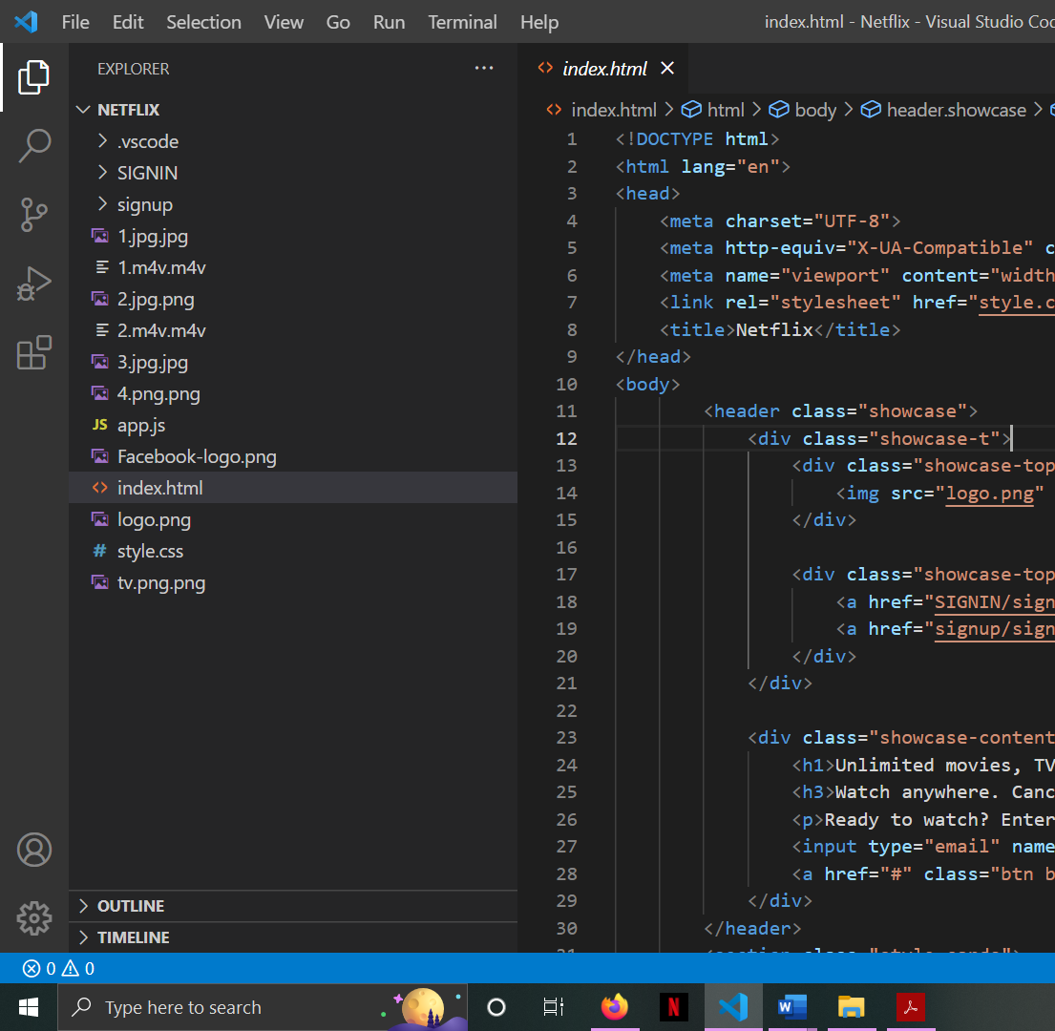

**SCREENSHOTS**

**4.1 Screenshots of the Code**

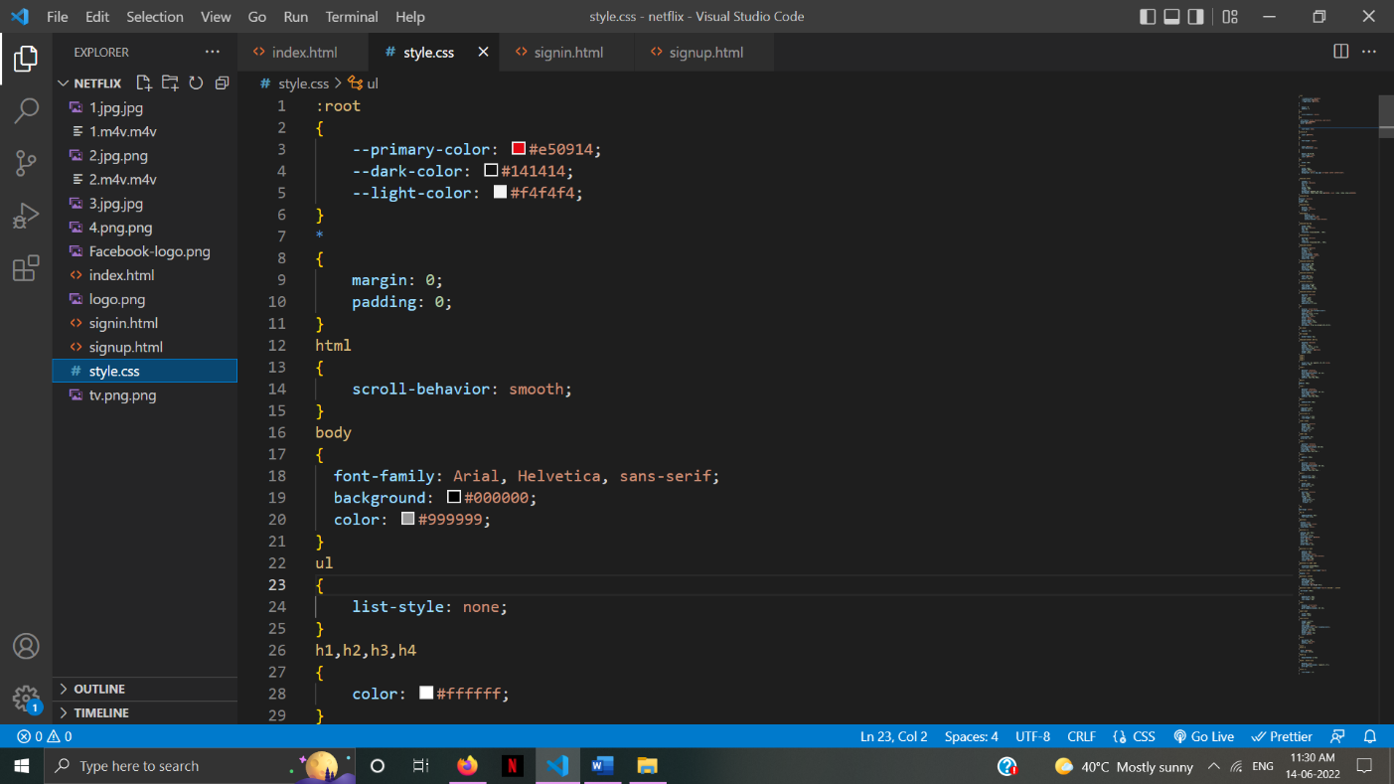

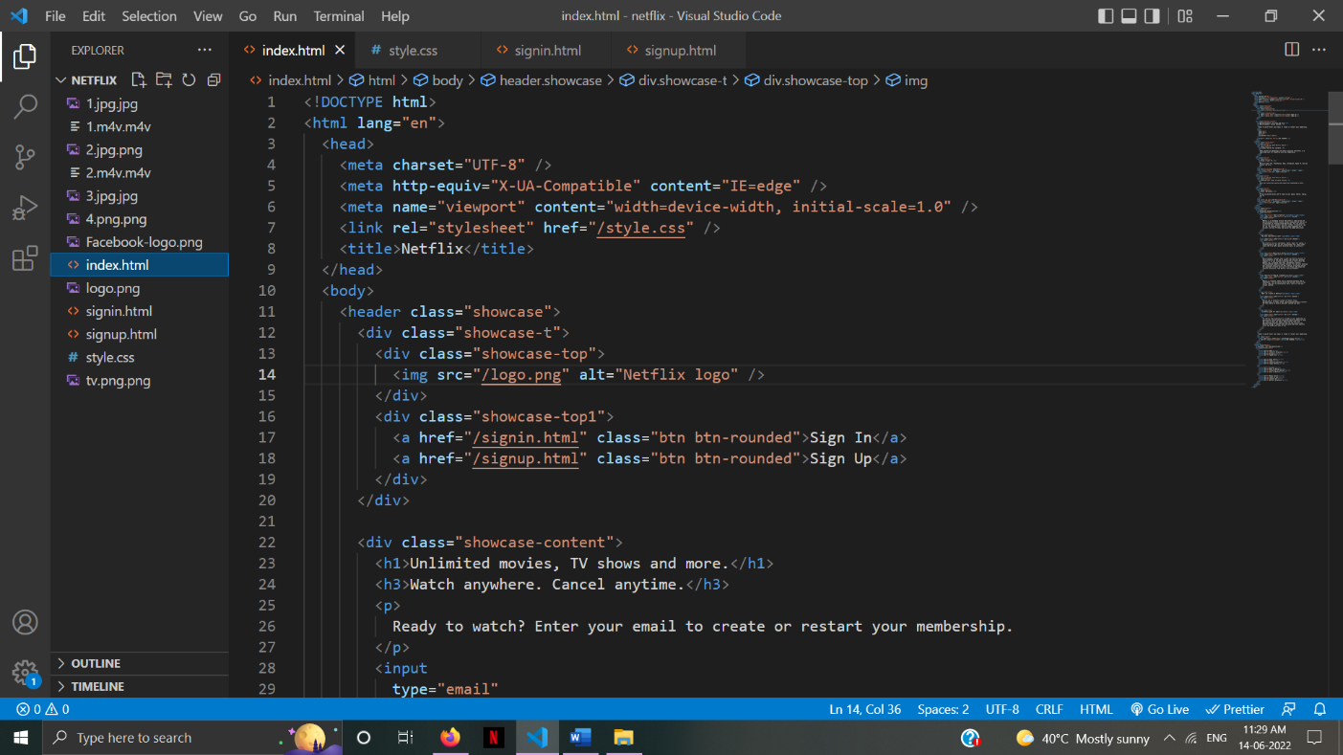

**4.2 Screenshots of the Website**

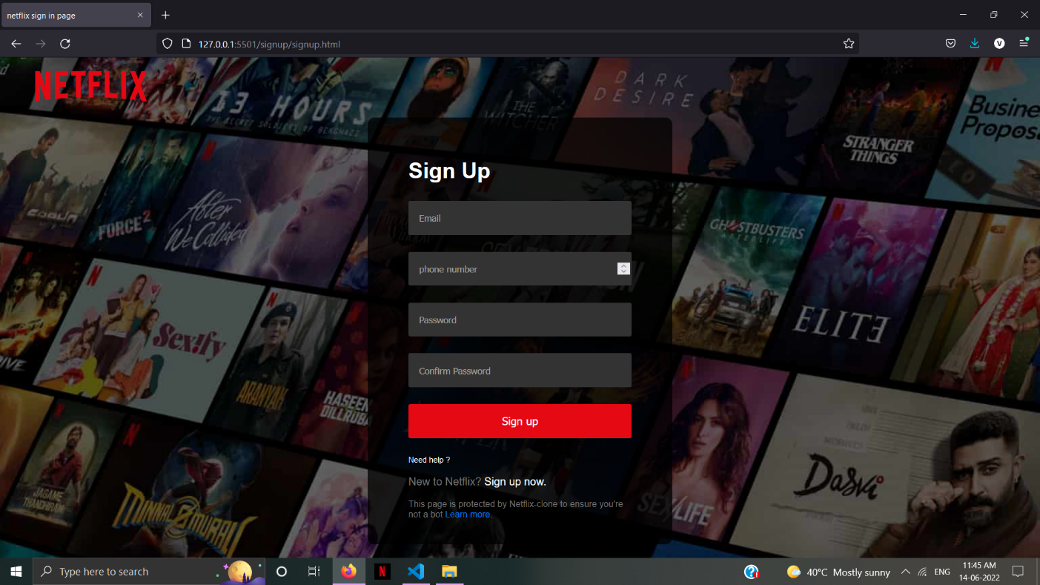

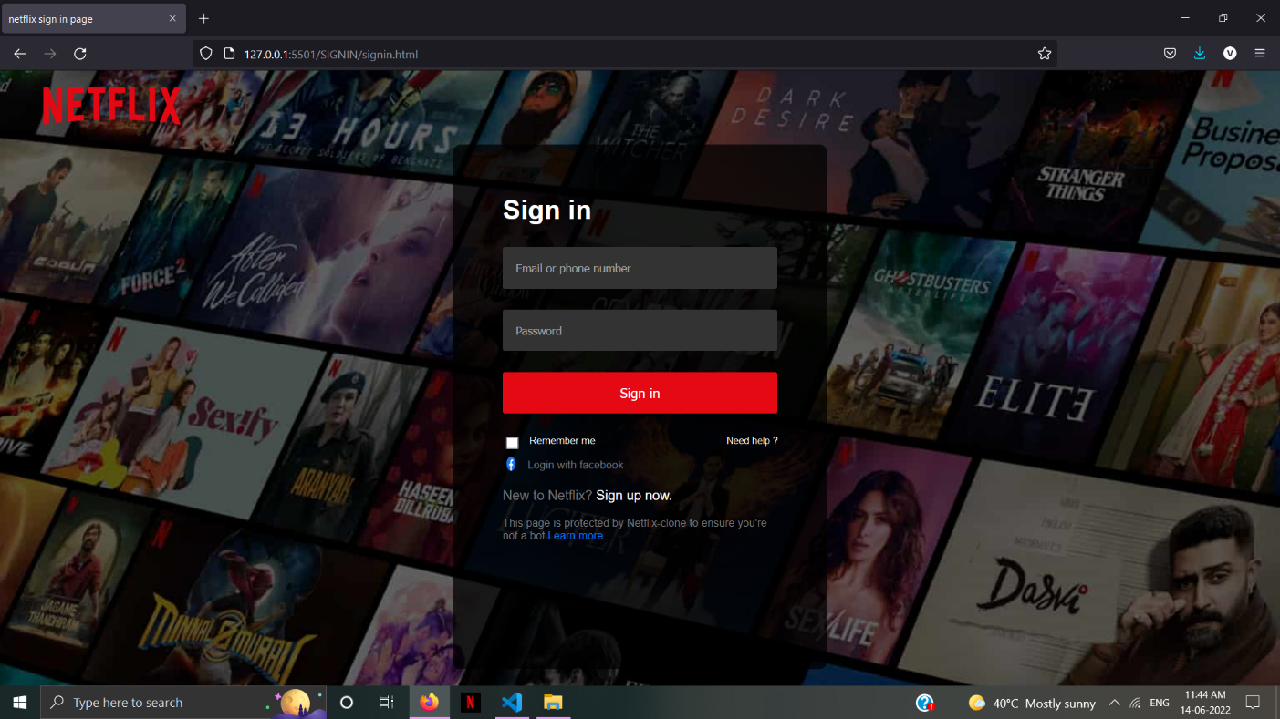

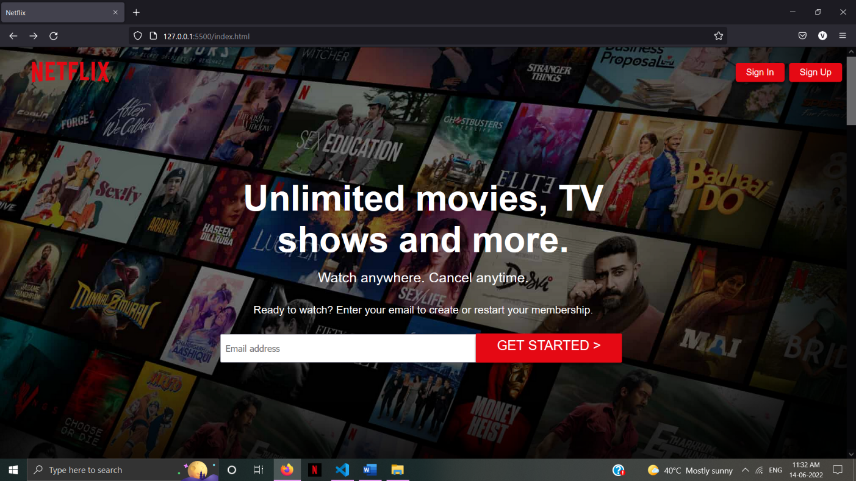

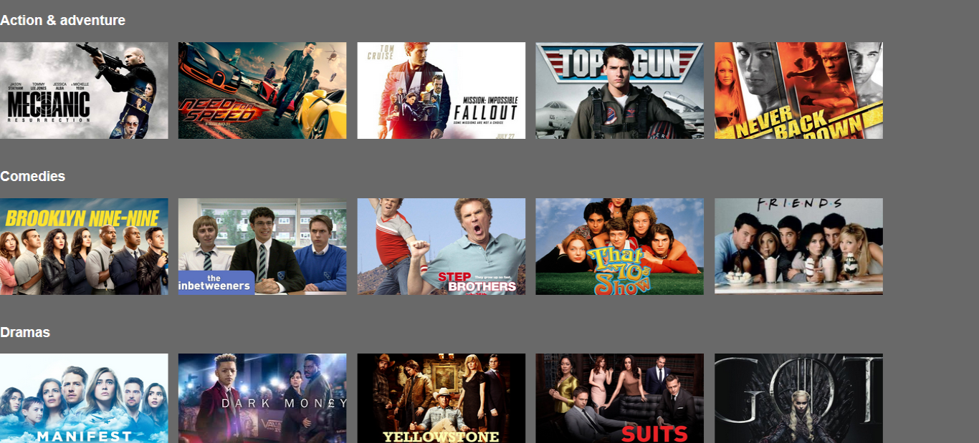

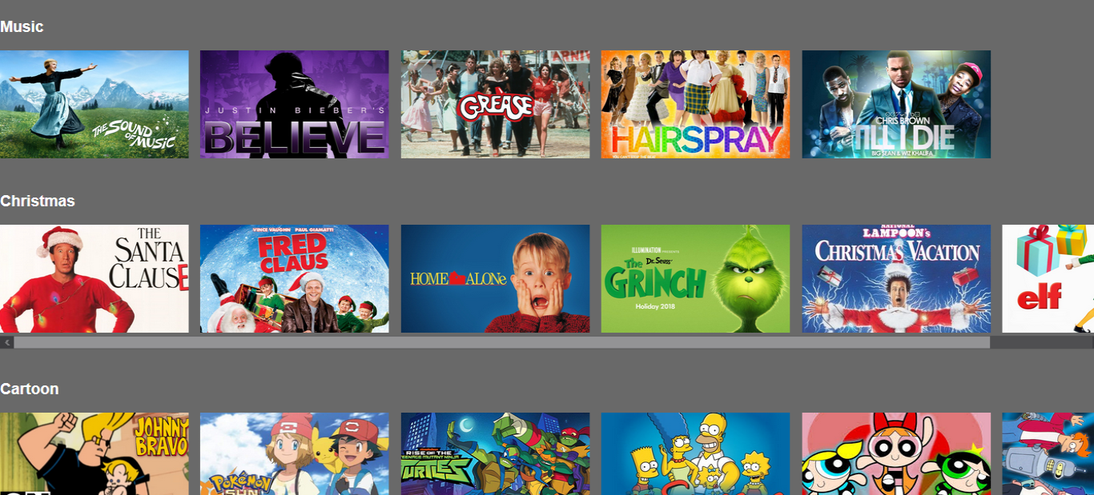

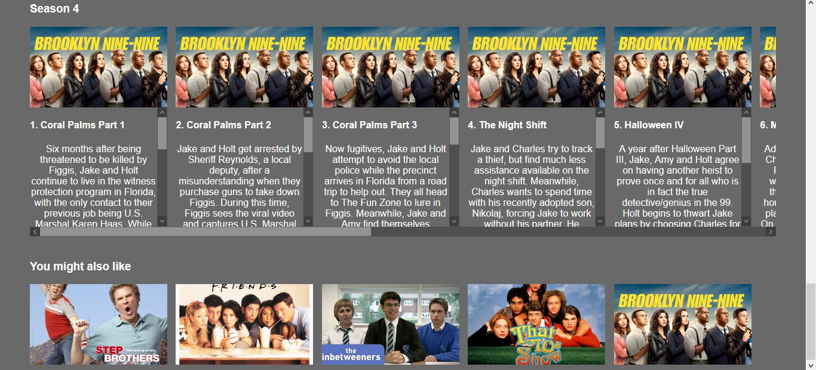

**REFERENCES**

5.1 <http://www.w3schools.com/>

5.2 <http://www.developer.mozilla.org/en-US/>

5.3 <http://www.udemy.com/>

5.4 <http://www.youtube.com/>

5.5 <https://www.wikipedia.org/>

5.6 Klinger, B. (2006). *Beyond the multiplex: Cinema, new technologies, and the home*. Berkeley: University of California Press. (191-197)

5.7 Napoli, P.M. (2011). Audience evolution: New technologies and the transformation of media audiences. New York: Columbia University Press.

5.8 Rose, F. (2011). *The art of immersion: How the digital generation is remaking Hollywood, Madison Avenue, and the way we tell stories*. New York: W.W. Norton & Co (107-190)